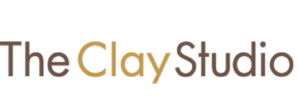
SLIDING SCALE TUITION

To encourage equity and access to our on-site classes, we are now offering Sliding Scale Tuition on select programs. Community Supported pricing is for those facing financial or other hardships, Standard pricing is the base cost, and Clay It Forward helps cover others in your program. There is no application for the different amounts — simply pay what works for you.

COMMUNITY SUPPORTED
(discount on Standard Tuition Rate)
STANDARD
(Base Tuition Rate)
CLAY IT FORWARD
(Standard Tuition Rate PLUS a donation toward community supported programming)

January 2022

