THE CLAY STUDIO’S CLAY FEST BRINGS FREE, HANDS-ON ACTIVITIES TO
SITE OF THEIR FUTURE HOME IN SOUTH KENSINGTON
A Community Event and Dinner Celebrate Creativity and Connection in the Studio’s New Neighborhood

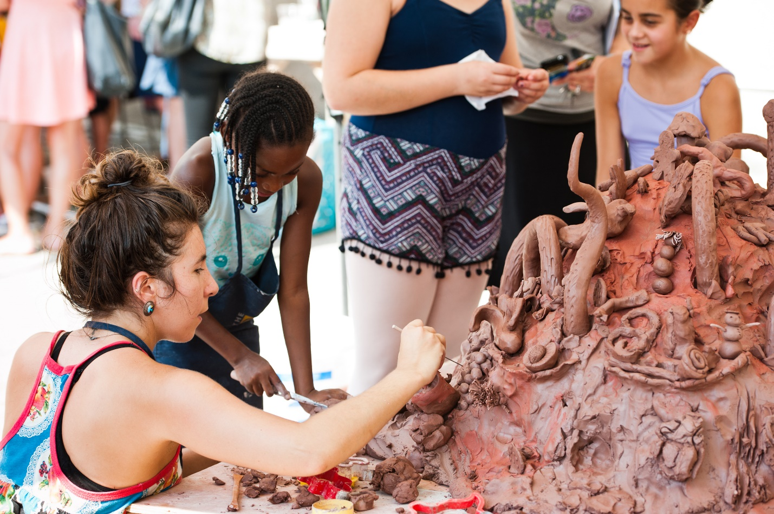

Philadelphia, PA – The Clay Studio welcomes all ages for a day of making, music, and muddy fun during the 4th annual Clay Fest presented by PNC Arts Alive on Saturday, September 29. Locals and visitors alike can explore the world of clay with a host of free outdoor activities at the site of The Clay Studio’s future home in South Kensington at 1425 N. American Street. Activities include a group sculpture extravaganza, wheel throwing, t-shirt making, artist demonstrations, raku pottery firing, an ice cream social, and more interactive programs.
“We’re excited to celebrate Clay Fest with our new friends and neighbors this year,” said Jennifer Martin, Executive Director of The Clay Studio. “This free event gives kids and adults in the community a chance to get together with us and discover the incredible art and craft of making ceramics. With The Clay Studio’s capital campaign in motion, and as we prepare and build support for our relocation to South Kensington in 2020, this is the perfect kind of block party to welcome in our future together.”
From 11 am – 3 pm, workshops bring out the playful artist in festival-goers as they try their hand at the potter’s wheel in Wheel Throwing 101, learn to glaze and fire pottery at Raku Firing, and bring characters and storylines to life using the art of stop motion during Clay Animation. Dessert lovers will enjoy tasting handmade ice cream from Little Baby’s Ice Cream while decorating ceramic bowls made by local artist Sasha Barrett at the Hands-on Ice Cream Social. Throughout the day, a group sculpting activity invites guests to help shape 1,000 pounds of clay into a collaborative masterpiece inspired by the South Kensington community.
In addition to clay-making projects, guests can craft a silk-screened t-shirt with Hope Rovelto, artist and owner of Little Chair Printing, and learn how to crochet yarn from recycled plastic bags (“plarn”) under the guidance of guest artist Rhonda Cooper of Marbufs during Plarn Bombing. At the Photo Booth, teaching artists from the Philadelphia Photo Arts Center will take on-the-spot pictures with a ceramic twist so attendees can commemorate their Clay Fest 2018 experience. The event will also feature music and food trucks including Pitruco Pizza and Katja's Empanadas.

Following the afternoon of hands-on activities, The Clay Studio will host a celebratory Community Maker Days Dinner from 6 pm – 9 pm for all who participated in a series of eight free Community Maker Days hosted this past summer to engage residents in and around the studio’s future neighborhood. Along with a complimentary buffet-style meal from local caterers Iris Brown and Ana Montañez, as well as local restaurants Al-Amana and Que Chula Es Puebla, attendees will enjoy musical performances by Philadelphia’s Familia Rojas and DJ Kiki Rodriguez. Guests will dine on the 300 plates collaboratively created and decorated during Community Maker Days, and participants will take home either the plate they decorated, or a plate made by another community maker. This event is open to anyone who participated in a Community Maker Days event or The Clay Studio’s spring Clay & Conversation series, as well as their friends and family. The Community Maker Days project is generously funded by the William Penn Foundation.
Both Clay Fest and the Community Maker Days Dinner take place at The Clay Studio’s future site, 1425 N. American Street in South Kensington. For more information, visit theclaystudio.org. Follow The Clay Studio on Facebook: @theclaystudio.phl; Twitter: @TheClayStudio; and Instagram: @theclaystudiophl.
###

About The Clay Studio
The Clay Studio is a nonprofit arts organization with internationally renowned artist residency programs, classes and events, exhibitions, community engagement programs, a shop, and more. We serve as a place where established and emerging artists come to shape their careers, a vital resource for arts education at local schools and community organizations, and a destination where people from all walks of life can explore the vast world of clay. Visit theclaystudio.org for more information.
About PNC Arts Alive
PNC Arts Alive is a multi-year, multi-million dollar grant initiative of the PNC Foundation, which receives its principal funding from The PNC Financial Services Group, Inc. In its ninth year, PNC Arts Alive challenges visual and performing arts organizations to put forth their best, most original thinking in expanding audience participation and engagement. A very prestigious grant, only twenty arts organizations in the Philadelphia and Southern New Jersey region are selected. Visit www.pncartsalive.com for more information.

